Alessia Ianni-Palarchio

Michelle Miller and Immony Men

Thesis I

October 22nd 2018

Novum: A Study in Interactive Science-Fiction

1. **Abstract**

This research looks into science-fiction entertainment, and how group-oriented, interactive experiences will influence the rest of the entertainment industry within the next ten to twenty years. In part, a study of historical entertainment trends and tropes will provide a basis for extrapolation, as well as what current developments have been made in general entertainment. To provide further information, a case study will be conducted and utilized as a primary resource, studying science-fiction entertainment with a group of participants. This study will be conducted on a multiplayer, augmented reality experience that pays homage to the story “TheAliens” by Murray Leinster. The data collected from the play experience will provide a valuable point to speculate further upon what future developments are more likely to occur. Secondary resources being referenced will be other relevant case studies, like the work of Gochfeld et al., as well as statistics currently available on lateral media fields. Likewise, impacts on controversial topics such as approaches to preserving media, will also be considered.

1. **Background and Research Questions**

Digital entertainment media is a lucrative industry, bringing in 13.66 billion dollars in the United States on home video content alone (Digital Entertainment Group) in 2017; in under 20 years, spending has risen to almost 20 times what it had been in 2000, when spending hadn’t even hit a billion dollars yet (see Table 1, *U.S. consumer spending on digital home entertainment 1999-2017*). With only a small stall in the 200Xs, for the past decade this has only been an uphill trend, with no signs of slowing or stopping. This indicates that there is a market that is willing to pay a great deal for the luxury of entertainment, and there will always be investment in areas where there is a large amount of cash inflow, due to the appeal of highly profitable business. That being said, ‘digital entertainment media’ encompasses a broad range of media types, beyond just video content, and some of such entertainment is not even located inside people’s homes!

|  |  |
| --- | --- |
| U.S. consumer spending on digital home entertainment 1999-2017 | |
| Consumer spending on digital home entertainment in the United States from 1999 to 2017 (in billion U.S. dollars) | |
| Year | Consumer spending in billion U.S. dollars |
| 1999 | 0.6 |
| 2000 | 0.7 |
| 2001 | 0.7 |
| 2002 | 0.7 |
| 2003 | 0.7 |
| 2004 | 0.7 |
| 2005 | 0.8 |
| 2006 | 1 |
| 2007 | 1.3 |
| 2008 | 1.6 |
| 2009 | 2.1 |
| 2010 | 2.5 |
| 2012 | 5.22 |
| 2013 | 6.49 |
| 2014 | 7.65 |
| 2015 | 9 |
| 2016 | 11.43 |
| 2017 | 13.66 |

External media seems to be even more lucrative, to a point. The revenue of movie theaters in the United States is estimated to be 16.62 billion in 2016 (US Census Bureau), compared to the 11.43 billion in home content. Yet, while consumers seem to like entertainment in both facets, many major types in the past have been either passive, or ‘solo’ experiences; these experiences are entirely valid, and provide a meaningful market on their own! However, only pointing to industries, like film or television, does not give the entire picture of ‘media’ as a whole. Video games come closest to providing digital ‘group’ experiences, but often people are separated by physical distance; likewise, the same issue arises with digital streaming, such as what Twitch and similar services cater to. There is an unfilled niche when regarding entertainment as a whole in digital experiences that are both geared towards group use that are also participatory, instead of passive.

Table 1 Digital Entertainment Group. "Consumer Spending on Digital Home Entertainment in The United States from 1999 to 2017 (in Billion U.S. Dollars)." Statista - The Statistics Portal, Statista, www.statista.com/statistics/188941/us-consumer-spendings-on-digital-distribution-since-1999/, Accessed 18 Sep 2018

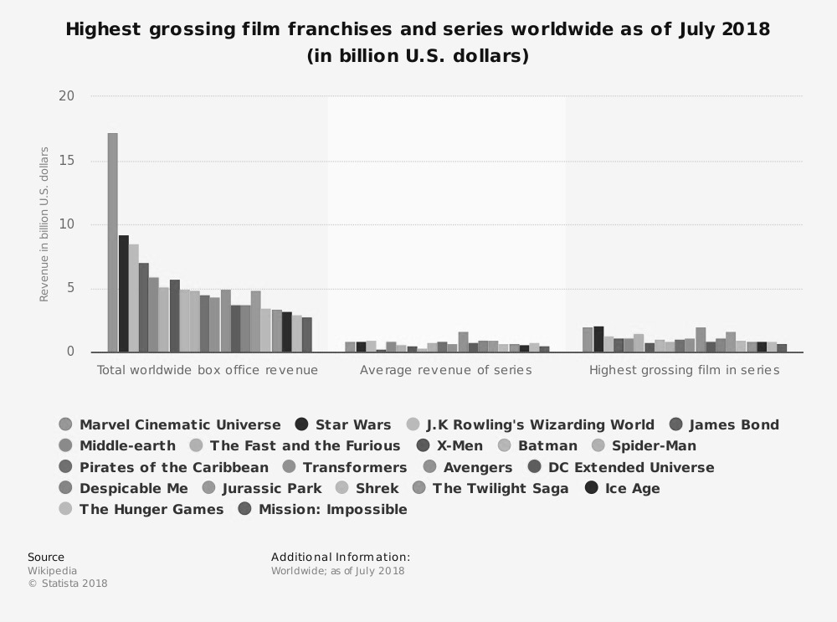In this niche, there are only a few notable examples to point to, and fewer still could be commercial successes. While the company The VOID has built a business around creating what they call ‘hyper-reality’ experiences (THE VOID), there has only been one study done that could hint at what this means for entertainment as a whole; that singular study was dubbed *Holojam in Wonderland* (Gochfeld et al.), and even that has only studied a single, fantasy genre experience for a linear story. Yet while fantasy is undoubtedly a popular genre, it is surpassed by science fiction in terms of popularity. Six of the ten highest grossing films in 2017 for North American audiences were science-fiction films, with the Star Wars instalment *The Last Jedi* topping that list at number one (Box Office Mojo). In fact, Star Wars as a franchise comes in second as the highest grossing franchise worldwide, only measuring lower than the Marvel Cinematic Universe (See Figure 1, *Highest Grossing Film Franchises and Series Worldwide as of July 2018 (in Billion U.S. Dollars)*)*.* Despite the proliferation of the science fiction genre in entertainment media, there is a lack of research pertaining to sci-fi and participatory entertainment.

Figure 1 Wikipedia. "Highest Grossing Film Franchises and Series Worldwide as of July 2018 (in Billion U.S. Dollars)." Statista - The Statistics Portal, Statista, www.statista.com/statistics/317408/highest-grossing-film-franchises-series/, Accessed 18 Sep 2018

Entertainment using alternative reality, such as augmented reality and virtual reality, also have merit in being researched; the Gartner hype cycle (see Image 1), which measures the ‘hype’ surrounding different technologies, has virtual reality is slated to be in the ‘plateau’ – a productive period – in two to five years. While augmented reality is in the trough of disillusionment at present, that does not negate its effect on entertainment media either; some companies such as Jaunt are migrating from VR to AR development (Robertson). Between the technological future that is forecast, and current trends, such as broader adoption in other industries that can encourage the further advancement of the technology that can support entertainment (Higgins, 86), they must be accounted for in the future of entertainment development. This leads me to ask the question, what impact will participatory, group oriented science-fiction experiences have on entertainment media?

Image 1 This is the current version of the Gartner hype cycle. ‘Top Trends in the Gartner Hype Cycle for Emerging Technologies, 2017’. Gartner, 15 Aug. 2017, https://www.gartner.com/smarterwithgartner/top-trends-in-the-gartner-hype-cycle-for-emerging-technologies-2017/.

1. **Project Objectives**

There are a few smaller questions that need to be answered along the way to knowing what the impact of this type of media will have on the broader entertainment industry. Part of this will be doing research on the history of entertainment media, to see prevalent tropes, themes, or patterns that have emerged when new media is developed. In tandem with this research, a case study will be compiled around a newly created interactive experience for users to experience. Thus far, the objective is to build the experience within Unity to deploy on multiple, synchronized devices so that a group can be using it, rather than just a singular individual; the final goal is to have created a multiplayer, co-operative augmented reality experience.

I will be conducting a survey as a part of my case study. This survey will provide additional data to answer the overall question being proposed for this paper. The survey will be in two parts:

Part one is a demographic survey to extrapolate from, mainly documenting the types of media people generally use, how long they use it for, and other related questions. This will help determine what demographic would be most likely to participate with this sort of media, as well as how long an engagement period they have.

Part two is for those that have actually participated in the experience, to determine what worked, what does, and whether or not they would participate again. Correlating this with demographic data about how much they typically spend on entertainment, as well as what they speculate they would spend on this particular type of media, we can postulate what the sort of market would be like (Please see the survey samples under Updated Scheduling and Documentation).

The experience portion of the case study will likely be around ten minutes– with an allowance for set-up time, and a brief training session for those participating as well. Play sessions will run before the above survey is provided to participants to fill out. During the play time, however, notes will also be taken on observations made during the sessions, such as what got a laugh out of people, if anything, or what parts players found trickier to accomplish, as well as anything they may struggle with during their sessions. This will provide data to extrapolate from to see what the market is like for users, what appeals to different user bases, current thoughts on alternate reality experiences, and can then support any secondary data that is referenced from alternate studies done on entertainment.

The worldbuilding of this augmented reality experience is based off of the story “The Aliens” by Murray Leinster; the story itself is in the public domain, but remains relevant to the current political climate. With the story being set in space, following the crew of a ship, *Novum* will pay homage to the story, and act as a precursor to it. With the objective being to test potential crew members for the crew spoken of in “The Aliens”,it does not strive to directly adapt but rather make reference to the impactful story, which will be displayed for participants and visitors to read as well if they wish.

1. **Theoretical/Critical Background and Framework**

Theoretically, this finds some grounding against video game design and development, in that there will always be a comparison between what is traditionally considered a game, and other digital media you interact with, such as film. Regarding genre, science-fiction has always been a nebulous term to define in a way that encompasses all its facets. Before being able to commence this study, defining the genre being used was a necessity that needed to be tackled, and Darko Suvin provided a much more inclusive proposition for the definition in his paper *On the Poetics of the Science Fiction Genre*. Suvin writes “I should like to approach such a discussion, and this field of discourse, by postulating a spectrum or spread of literary subject-matter, running from the ideal extreme of exact recreation of the author's empirical environment to exclusive interest in a strange newness, a novum” (373). Using Suvin’s work as a basis, for the purposes of this study, science-fiction will be defined as any body of work that embodies the idea of '*novum'* as a major concept in its identity. In homage to Suvin’s work, the title of this paper and the experience will both be entitled *‘novum’.*

As well, it will find a place alongside the study of *Holojam in Wonderland,* and any other related studies if they exist. *Holojam in Wonderland* is about interactive mixed reality theater, and the retelling of the Alice in Wonderland story. Focused on whether or not such media is entertaining, the team put an emphasis on why VR was the best medium, stating “VR still has a strong novelty appeal, which helps attract an audience, but that is not a sufficient reason to use it to tell a story. We sought to demonstrate not just how to use VR for a theatrical experience, but why to do so. What sorts of stories would benefit from being told in virtual reality?” (Gochfeld et al. 365) Following up on this, it is not just fantasy that could benefit from VR storytelling; science-fiction would also suit the medium, with the fantastical elements present in many science-fiction stories. This leads to the conclusion that is it worth exploring other genres in virtual reality, as well as in mixed reality applications.

Lending to this notion is the paper *The Role of Transportation in the Persuasiveness of Public Narratives* by Melanie C. Green and Timothy C. Brock, which deals with transportation theory and narratives. Transportation theory is based on the idea of the user being ‘transported’ to the world setting of the story they are observing or interacting with. It deals with the concept of immersion, and how a viewer or player can get lost in a story. Green and Brock list that “[t]he components of transportation include emotional reactions, mental imagery, and a loss of access to real-world information; the resulting transportation may be a mechanism for narrative-based belief change” (Green and Brock 703). While they speak to narrative as a whole, virtual reality, augmented reality, extended reality, and mixed reality, all have the loss of access to real world information as a part of the medium to varying degrees, with virtual reality being the highest connection loss. Through this, we can infer that these four mediums are innately more immersive than traditional forms of storytelling. Green and Brock also state that “people are motivated to at least temporarily accept a fictional world, often for enjoyment purposes” (702). This acceptance is backed up with the fact that in another study, “[p]articipants knew for sure that nothing real was happening, but they still tended to respond as if they were causing harm to the virtual  Learner –  in spite of the very simple rendering of the character representing the Learner (since presence is not even about realism)” (Slater 432 - 433). Through both of these, it serves a point that as technology becomes more advanced, and becomes more adept at supplying environments that suspend our disbelief, the greater this disconnection from the real world will be. With audiences more readily accepting their environment, storytelling will struggle less with creating that suspension of disbelief and can focus more on providing the user with a compelling experience instead.

This leads to the story itself. Leinster very blatantly speaks about xenophobia in his book “The Aliens”. Politically and socially, this feels relevant in two ways. The first, in that science fiction often does still find roots in morals and ideals and often finds a basis in something political. Star Wars’ Imperials are based off of Nazis, and arguably, the First Order can be construed as being based off of Neo-Nazism. Likewise, there are also bio-politics, as Vint mentions in Science Fiction and Biopolitics, stating that;

*In a biocultural age, understanding the speculative discourses of biopolitics is imperative, and [science fiction] is in a privileged position to help us think through its anxieties and contradictions: the complicated parenting of IVF and other assistive reproductive technologies, including ideas of 'designer' babies, evoked in films such as Splice (Natali Canada/France/US 2009); the fear of pandemics, often conflated with the spectre of bioterrorism to produce narratives about virulent disease and equally treacherous carriers, as in 28 Days Later (Boyle UK 2002); the new economics of patented life forms and privatised food, presented as a nightmare which leads to cannibalism in Pandorum (Alvart Germany/UK 2009) (161 – 162).*

Biopolitics is not the only political factor that science fiction has the capability and obligation to bring forth. Which brings forth present relevance; regardless of personal views on Donald Trump, his proposed ‘Space Force’ creeps into the territory that “The Aliens” discusses. Militarizing space has its own complications, and while currently it is not slated for defensive or fighting with extraterrestrials (Durkin), considering problems of racism and discrimination that continue to dig their roots into society, it is not a far leap to see how that would continue to extend to any other species we might meet. Both of these ensure that “The Aliens” is not only a relevant work to reference, but provides something of an optimistic outlook a well, should one end up reading the story after having heard of it from Novum.

**Methodology**

I shall be using the IDEO Design Thinking methodology while constructing my case study (See Image 1). Already step one has been fulfilled in the brainstorming of the overall question of this paper and step two is well underway. Current inspiration being gathered includes science fiction work that is either a personal inspiration, to dissect what makes each piece so memorable, as well as which science fiction works are financially successful. This is closely linked with step three in the process, which is to generate ideas. Both for the paper and the case study build, this step is still in process, and steps three, four and five will be continuously carried out through the next months. Finally, at the conclusion of this project, step six will be to share it, to both my peers and potentially a larger audience.

IDEO’s design is based off of the principles of human-centered design (abbreviated just as HCD) (‘Design Thinking’); as written in Eyal Eshet’s paper *Human-Centered Design in Mobile Application Development: Emerging Methods*, they summarize the necessity of such design practices in saying that “the HCD approach provides a solid framework of high-level activities for developing interactive systems based on the end-user perspective… Their evolution addresses developments in technology, which becomes more embedded in our lifestyle. Consequently, peoples' relationship with the technology becomes more intimate” (9). Digital development as a whole should follow these principles, not just for application development. Anything that requires a user or participant to interact or react to a digital interface of any sort, it should be tailored in a way that the user does not have to fight with the technology. It should not be taken as a magical fix all when it comes to design, but rather a consideration to creating seamless experiences that are an ease to use, rather than the attempt to complete an activity or task becoming more prevalent than the activity or task itself.

Image 2 ‘Design Thinking: A Method for Creative Problem Solving’. IDEO U, https://www.ideou.com/pages/design-thinking. Accessed 18 Sept. 2018.



Using a design thinking methodology seemed much more apt than adopting an AGILE Scrum methodology instead, which relies on using short sprint sessions to accomplish a larger task. This method is often used to avoid bottlenecking a project by never letting too long go without check–ins or updates, and often heard of in business workplaces. Higuchi and Nakano point out in their paper *Agile Design: A Combined Model Based on Design Thinking and Agile Methodologies for Digital Games Projects* that SCRUM and Design Thinking do have some similarities between them. However, while Higuchi and Nakano state that “as expected, game developers already use Agile Methodologies in their game development process. It was also observed that the most popular AM among developers is the SCRUM,”(Higuchi et al. 123) since this has such a heavy reliance on meetings to consolidate work and advance progress, it did not seem like the right methodology to employ for a single person team. This also has some timeline limitations, as due to the scope of the project, iterations can only be made in smaller segments, rather than major overhauls to keep to a coherent piece with a coherent schedule.

Taking this in a broader scope, while IDEO is ideal for their push to tell a story at the end of their process, design thinking as a school of thought is applicable for various applications in a context lateral to ‘game making’. As stated in *Making Computer Games and Design Thinking: A Review of Current Software and Strategies*, “[d]esign thinking, as the ability to think about—and influence—social systems, can thus be a precursor to learning how to negotiate the complexities of modern life” (Hayes and Games 328). It is namely the influence and thought on social systems that is most applicable in the context of multi-user experiences. Like multi-player, there is an innate social aspect to be explored through the interactions between participants, and between participants and the environment they are interacting with or observing. The five step process is similar to IDEO’s, with the steps being *empathize 🡪 define 🡪 ideate 🡪 prototype 🡪 test* (‘Design Thinking Bootleg’). Empathize process to be the most different, aside from the lack of a ‘sharing’ stage at the end; empathy in design thinking is about leaning about the humans that human centered design products are being geared towards (‘Design Thinking Bootleg - Deck’). Using both these processes together will benefit the user, as the product – in this case, the experience – will be catered towards them, and their values.

1. **Resources and Facilities**

Resources challenges for hardware setup are listed in *the Potential Challenges and Limitations* portion of this paper For development, I have access to a single Pixel 2 XL phone that runs ARCore, and a Mac laptop capable of running Unity, the server, as well as any other generation of assets through the use of the Adobe suite.

A final setup will require physical space of a thus undetermined size, and potential human support depending on how complicated it becomes to setup for testers. Likewise some props will be required, such as a projector to make use of a screen and a larger target image, good room lighting, as well as tables that other props can be placed upon. This space may need to be fairly large, and setup time is a potential challenge – especially if there are a large number of image markers that need to be reset properly after every session is completed.

As for people I can ask for help with if needed, Emma Westecott and Hector Centeno are both people with experience in games and in Unity; their expertise is good to reference as they have a wide knowledgebase on the topics and can provide valuable advice.

1. **Potential Challenges and Limitations**

As a theoretical challenge, obtaining a proper sample size for a suitable survey could prove to be difficult. Thus far, I have no way to obtain a sampling frame to do probability sampling, but non-probability sampling will not have the same use for extrapolating data. Otherwise, research has gone smoothly and there is a fair body of work to be able to situate the case study in.

Technologically, some of the biggest setbacks have been in occurring bugs thus far, which could hamper the polish of the final build; some of these bugs are APK bugs, such as a major bug in ARCore that caused errors based on the folder structure of the project. Another large challenge is in finding the proper hardware to actually run the project. While I have access to a Pixel 2 XL, which does run ARCore, finding other compatible phones that are inexpensive and could be used in a public setup is proving to be a difficult challenge. One possible untested solution is trying to use rooted phones instead to install ARCore on unsupported android devices instead.

There is currently scope limitations being addressed, in the form of reducing the scope at the moment to accommodate a finished project. The original build size was too ambitious to tackle all at once, and is thus being limited to a smaller build size to try and accomplish more in the time provided.

As a field of study in itself, the technology also poses a challenge. Specifically, as mentioned by Bujari et al in –––– mention that “[a]n increasing interest is coming also from researchers due to the technical challenges of AR applications” (2). Specifically they single out cooperative AR gaming as having a large number of technical challenges to overcome, especially in terms of where, what they call ‘computational load’ is being placed. With augmented reality allowing you to roam, it becomes a challenge of how to host local servers for players who are together, without putting the burden on one of the player’s devices. This is less of an issue for site-specific experiences, since the site itself will undoubtedly have a server present, regardless of the medium, however anything disseminated to the public will have a difference issue.

This also leads into challenge two, also regarding technology, and this is in dealing with cost and obsolescence (planned or otherwise). The largest example is apparent in Bishop’s article entitled “The Dream of DisneyQuest Is Dead”. Bishop writes that ““We knew the equipment was too expensive to be practical,” says one former employee who asked not to be named because their current employer hasn’t permitted them to do interviews, though they are no longer at Disney. “But the goal was to buy our way into the future, to learn about VR 10-plus years before everyone else.”” This technology, however, did not remain as the technology of the future forever; upkeep is expensive, and at a certain point, is no longer worth it to try and maintain. With technology snowballing in capabilities and upgrades, and changes coming out at least yearly, there will remain the question of how meaningful experiences be created where they will not be obsolete within a year or so of creation.

1. **Significance of the Project**

This project will hold significance in an emerging body of work with studies like *Holojam in Wonderland* (Gochfeld et al.).Not only will it seek to categorize current technologies, and provide speculation on the future of an industry, but will also begin to formulate academic work so that we have a body to reference in the future as an academic community. This also hopes to promote the proper preservation of emerging works and experiences before it becomes a problem such as with video games specifically, where many games have not been properly preserved and are no longer around for study, or where it has fallen to the player community to preserve games in a legally-gray area; this is mentioned by Bachell and Barr in *Video Game Preservation in the UK: Independent Games Developers’ Records Management Practices*, that “[f]an-based initiatives now represent some of the most active groups in preserving gaming heritage, which have attracted the interest of more established institutions, who must consider how the growing wealth of fan expertise and resources can be utilised in future projects, or if they should be used at all” (143). With no established industry standards, and fan preservation being more comprehensive collections of digital games, there is already a dangerous precedent being set for other forms of entertainment media; this danger only grows regarding both the history of alternate reality experiences, specifically in virtual reality, only compounded by many of alternate reality experiences fitting into the ‘digital games’ umbrella as well.

Looking at the history of VR specifically, the original virtual experiences were not classified as such because he terminology did not exist to describe them yet. The Link Trainer simulation is considered one of the earliest ‘VR’ experiences (Jeon 38) (Pope 6), and it was a flying simulator that was used by pilots to train and experience what actually flying was supposed to be like, minus the actual aircraft. Pope writes in a paper titled *Introduction to Virtual and Augmented Reality* that While other fictional genres have kept the idea alive, The Matrix (1999) is considered to be the driving factor for public interest in VR (Pope, 6). The history is harder to trace since the terms were not coined until long after conception, such as Tom Caddell in 1990 coining the term augmented reality (Pope 7); creating a body of academic study now that these terms and the language to describe them exists are needed to help promote the study of augmented, virtual, extended, and mixed reality as used in entertainment as a valid area of study, which in turn will promote talk around proper preservation of works.

Likewise, while digital games are often persevered through ROM dumping and emulation, and movies through ripping and streaming, these multi-‘player’ or multi-participant experiences would not be able to be preserved by the community in the same manner. Since many of these would require specialized setups and are displayed on site locations, there are no files accessible to the public to preserve in lieu of companies and developers taking the initiative to preserve the work. Short of insiders leaking the files, they would be lost forever without proper preservation methods in place for both the hardware and software aspects.

1. **Updated Schedule**

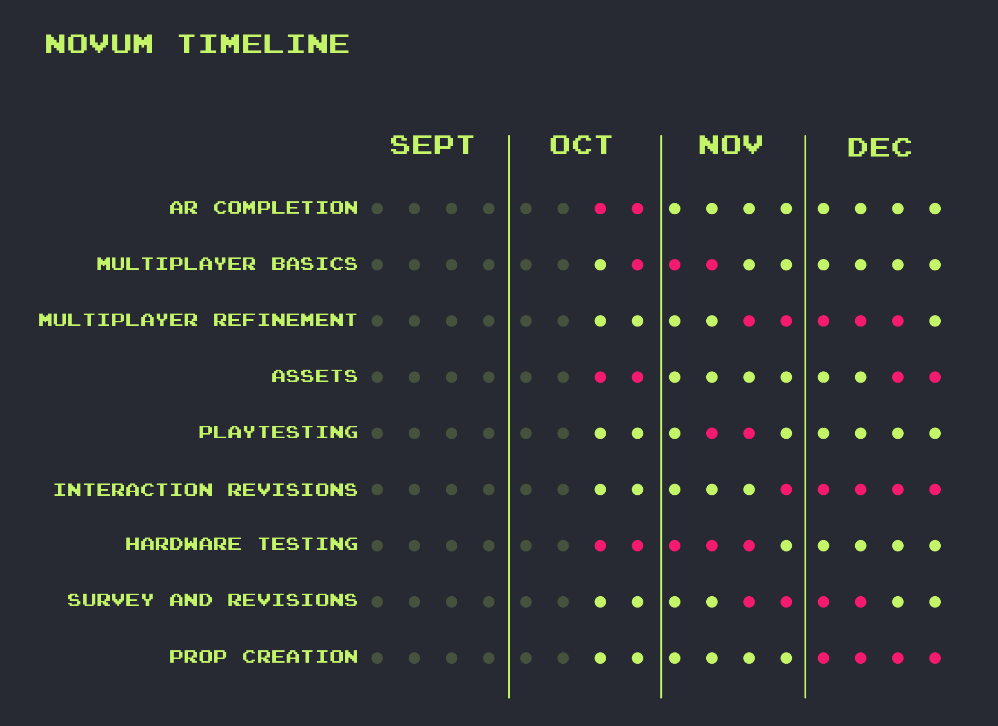

This schedule does not take into account final deadlines, and will still shift based on feedback that has been given. Prop creation will be moved up in priority and in time, to ensure that is it completed to a useable state before the end of November. Some setbacks have been as follows:

* Programming errors
* ARCore SDK file path bug
* Android multithread bug
* Programming errors
* ARCore SDK file path bug
* Android multithread bug
* Hardware concerns

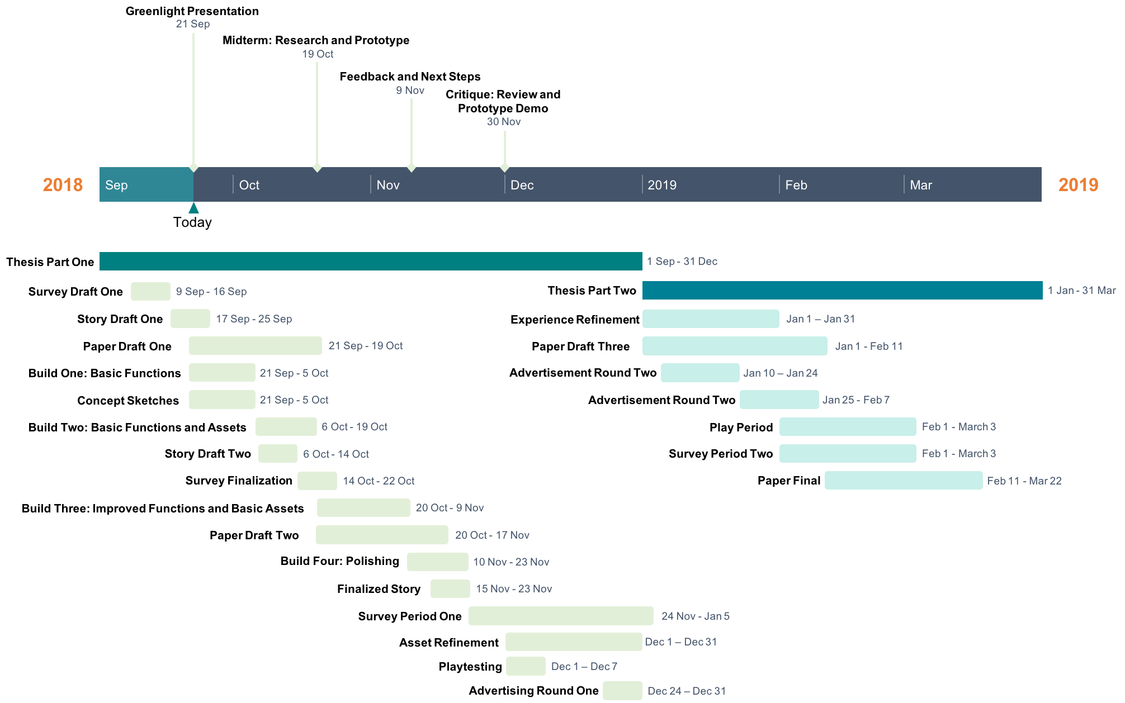**Original Schedule**

**Documentation Via Scheduling**

Below, documentation and progress will be recorded as a record of each scheduled point to keep track of progress, deadlines, and roadblocks. Photo documentation will be added where applicable.

1. Survey Draft One – Complete Draft

This was developed with answering some of the questions at hand in mind. It includes demographic questions, as well as media related questions to determine the audience of this survey and this study. Later questions are meant to help determine engagement, and potential repeat visits to similar experiences. This survey is subject to change to ensure the questions remain unbiased, and properly target points that answer the initial questions of this project.

1. What is your age?
   1. Under 18 years old
   2. 18 to 30
   3. 31 to 50
   4. 51 to 70
   5. Over 70
2. What do you do? (Select all that apply)
   1. Work
   2. Undergrad Student
   3. Highschool student
   4. Masters student
   5. PHD student
   6. Other
3. Given that this is an open survey, have you completed this survey before?
4. How much time every **week** do you typically spend engaged with entertainment media?
   1. Less than 1 hour
   2. 1 – 3 hours
   3. 4 – 6 hours
   4. 7 – 9 hours
   5. Over 9 hours
5. How long do you typically spend **in a single, continuous sitting,** engaged with entertainment media?
   1. Less than 10 minutes
   2. 10 – 20 minutes
   3. 21 – 40 minutes
   4. 41 – 60 minutes
   5. Over 60 minutes
6. Rank the entertainment you use most often from 1 to 9, with one being what you engage with most often, and 9 being what you engage in least often.
   1. TV and Movies (including streaming services)
   2. Radio
   3. Reading (Books, magazines, manga, comics)
   4. Video Games (Console, handheld, mobile and web)
   5. Web entertainment (YouTube, Social Media, etc. Not including games found on the web)
   6. Tabletop games (board, dice, card, miniature, or tile based games)
   7. Music and podcasts (Not including orchestra and concerts)
   8. Live entertainment (Theater, orchestra, concerts)
   9. Exhibition entertainment (museums, art shows, fairs)
7. On a scale rate your level of interest in the following media – movies, tv, streaming services, video games, tabletop games:
8. Have you done a mixed reality, virtual reality or augmented reality experience or game before?
9. Is there a type of entertainment you use that is missing from the above list?

[Written answer]

1. Do you find most of your time on entertainment is spent inside your home, or outside of it?
2. What genre do you engage with the most?
   1. Dropdown with genres – for aggregate
3. Do you prefer independent or mainstream media?
4. How much do you typically spend on entertainment media per month?
   1. Under $10
   2. $10 - $20
   3. $21 - $30
   4. $31 - $40
   5. $41 - $50
   6. $51 – $60
   7. $61 - $70
   8. $71 – $80
   9. +$80
5. Which do you prefer more? Entertainment you can enjoy alone, or entertainment that is enjoyed in a group?
6. What do you think is the biggest problem with current entertainment media?
   1. Too expensive
   2. Boring content
   3. Not accessible
   4. Lack of originality
   5. Other [Write]
7. Did you play our experience?

Yes/no answer.

­­––

[Questions under this line are only to be answered if the answer to number 16 is a yes]

1. How many times did you participate?
2. How long did you spend in our experience?
3. Ease of use
4. On a scale of 1 to 10, how enjoyable did you find experience, with 1 being the most enjoyable possible, and 10 being the least.
5. Would you do it again?

Yes/no answer.

1. How much would you pay (in CAD) for an experience like this?
   1. I wouldn’t pay at all for it/it isn’t worth paying for
   2. Under $10
   3. $10 - $20
   4. $21 - $30
   5. $31 - $40
   6. $41 - $50
   7. +$50
2. What was your favorite part of the experience?
3. What do you think can be improved on the most?
4. Would you prefer to go out for this, or be able to put it in your own home?
5. Do you have any additional feedback?
6. Story Draft One – In Progress

A group of individuals come in for ‘training’ – they have been selected to work as a part of a special, new program. The description is purposefully vague and obfuscates the purpose of what they are training for. Each of them will be set-up with a ‘training headset’, and only referred to as a number (the number on their headset)!

They will be given a brief introductory ‘welcome video’ short, which serves as a brief exposition as well as serving to outline their task, while under the same ‘business hire’ premise. –– Everyone will be hearing the same dialogue for this portion. Either it is to become a team of scientists, or space explorers, or some job that does require a much larger amount of training.

Then the group will be given leeway to try and accomplish the task set out before them. A number of physical objects with digital representations will be present for interaction. Likely one side will be targeted, or have multi-targeted images rather than utilize object recognition, and individual interactions will generate either a positive or negative outcome within the experience, leading to either a success or failure at the end of the encounter. Each interaction will likely use falsified jargon to make it sound technical in a satirical way, in reference to made up ‘science’ terms used in fiction.

Like the *Holojam in Wonderland* project, there is also the potential to adapt a current piece of literature, save for ensuring it is in the science-fiction genre instead. Two potential public domain contenders in fiction are *The Black Star Passes* by Jr. John W. Campbell, or *The Aliens* by Murray Leinster.

1. 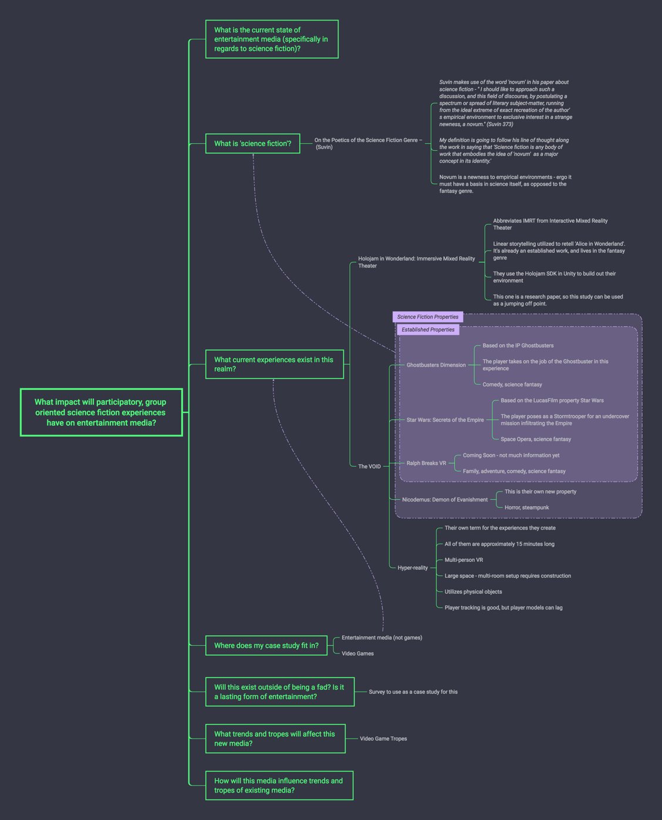Paper Draft One – In Progress

Mind mapping is helping me out to answer the main questions being posed for this research paper, and to organize my thoughts under each individual point. As well, it is a good way to keep track of sources being used and what they fall under for ease of reference.

1. Build One – Basic Functions

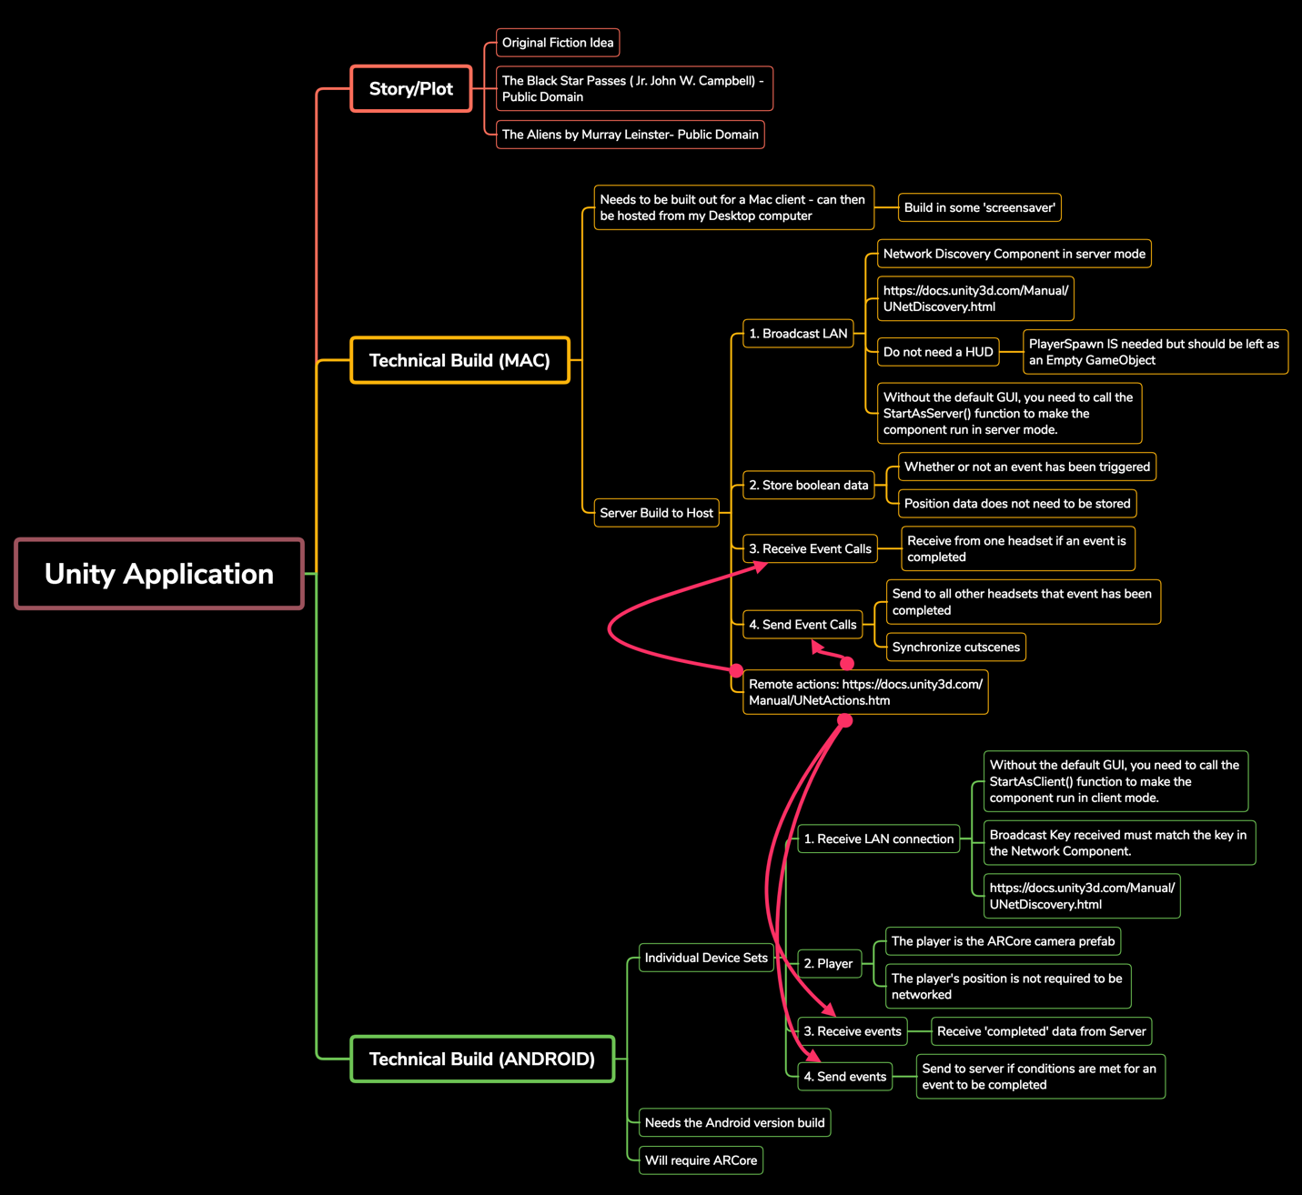

Currently I have a rough build plan, as follows in the image above. This has the basic needs of both the Mac server build, and the Android client build of the project. As well, there is currently a GitHub repository that I have set up to host my code on, and to version control what I am working on (alessia-ip).

**Newly Completed Build Work**

* Voiceover content using IBM’s Watson – this uses the British voice!

<p><s>Welcome to project Novum, and thank you for volunteering as participants. <break time="300ms"/>  <prosody rate="+5%">You will be undergoing a series of tests to serve aboard the Niccola space ship, with your first destination being the Theta Gisol solar system should you pass this series of tests. </prosody> <break time="100ms"/> <prosody rate="-5%">With the purpose being locating the home of the Plumies, only those that demonstrate the necessary skills will be accepted to the program.</prosody> <break time="300ms"/> Do follow all instructions during the duration of this test. Thank you. Your test will begin momentarily. </s></p>

<p><s><prosody rate="+15%">Please <break time="100ms"/> locate your test ship and place it on the landing pad to prove your flight skills.</prosody></s></p>

<p><s><prosody rate="+15%" >Congratulations! You have successfully completed your first test.</prosody></s></p>

* GUI Skins – mainly to make setup menus legible
* One prefab per image target instead of one prefab for all targets
* ARCore does support continuous target tracking – implemented a faster rate for prefab position adjustment but it’s choppy.
* Event scripting – when audio cues trigger, success setups
* GUI Skins – mainly to make setup menus legible
* One prefab per image target instead of one prefab for all targets
* ARCore does support continuous target tracking – implemented a faster rate for prefab position adjustment but it’s choppy.
* Event scripting – when audio cues trigger, success setups

**Updated Survey**



 





Scope Changes

Since I am having an immense amount of setbacks getting the networking working, I am scoping to manage the co-op portion solely using physical changes in items for the moment. This will allow me to keep a functioning experience, and then I can re-implement working networking over the December break. This leaves for more time to focus on the physical assets and setup of the experience itself.

Game Flow

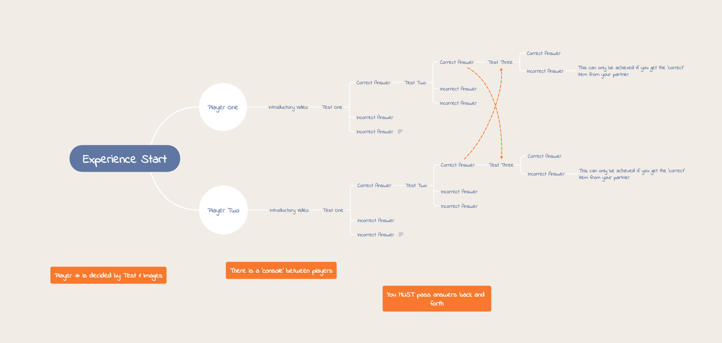

Script

Script for Novum

Narrator – first video:

Welcome to project Novum, and thank you for volunteering as participants. You will be undergoing a series of tests to serve aboard the Niccola space ship, with your first destination being the Theta Gisol solar system, should you pass this series of tests. With the purpose being locating the home of the Plumies, only those that demonstrate the necessary skills will be accepted to the program. Do follow all instructions during the duration of this test. Thank you. Your test will begin momentarily.

After this video, the rest of the ‘objects’ will become active to select. They’ll all be upside down to start, with various answers on them. The correct answer will need to be flipped upright.

Narrator – audio only:

Please, follow through on your test by correctly answering the following questions. Turn over the appropriate items when directed to do so.

Narrator – audio only:

You are currently undergoing maintenance on your ship. Your companion suggests that you need a break, and that watching the radar while at a standstill is unnecessary. Do you: go with them, resume your work, or report to your Captain for insubordination?

Depending on the answer, your score changes, to be announced at the end.

Narrator – audio only:

Please select the most important tool for space travel by turning over the appropriate object.

Three ‘tools’ will be provided, hovering over their respective blocks. Depending on the answer, your score changes, to be announced at the end.

Narrator – audio only:

Your colleague is agreeing to speak with the aliens you encounter – the Plumies. Should you: have them detained, or engage in discussion with our first contact?

The player has to select one of the following. That item will be passed to the player opposite them, through the console.

Narrator – audio only:

Pass this item to your companion through the console.

Narrator – audio only:

You will receive an item in return. Please, open the item.

Narrator – audio only:

(if you’ve been sold out/betrayed) You will be detained shortly. Unfortunately, you are a risk if you work with the Plumie.   
  
 Narrator – audio only:

(if you’ve been assisted) You and your companion are likely to have a very nice trip.

Narrator – Video:

(if you’ve been assisted) Thank you for applying. Your application will be considered.

The ‘best’ set of options is ‘report, correct item (weapon), report, and being unreported’ to play off the initial themes in the book.

1. **Bibliography**

alessia-ip. *Novum*. Thesis. 2018. 2018. GitHub, https://github.com/alessia-ip/Novum.

Bachell, Alasdair, and Matthew Barr. *View of Video Game Preservation in the UK: A Survey of Records Management Practices.* Oct. 2014, doi:10.2218/ijdc.v9i2.294.

Bishop, Rollin. ‘The Dream of DisneyQuest Is Dead’. Polygon, 18 Oct. 2018, https://www.polygon.com/features/2018/10/18/17888722/disneyquest-disney-vr-closed

Box Office Mojo. "Box Office Revenue of The Highest Grossing Movies in North America in 2017 (in Million U.S. Dollars)." *Statista - The Statistics Portal,* Statista, www.statista.com/statistics/794432/box-office-revenue-of-the-top-grossing-movies/, Accessed 18 Sep 2018

Bujari, Armir, et al. ‘Optimal Configuration of Active and Backup Servers for Augmented Reality Cooperative Games’. Concurrency and Computation: Practice and Experience, vol. 30, no. 20, Oct. 2018, p. e4454. Wiley Online Library, doi:10.1002/cpe.4454.

Campbell, John W., et al. *The Black Star Passes.* Ace Books, Inc., 1953. Project Gutenburg , www.gutenberg.org/ebooks/20707.

Cummings, James J., and Jeremy N. Bailenson. ‘How Immersive Is Enough? A Meta-Analysis of the Effect of Immersive Technology on User Presence’. Media Psychology, vol. 19, no. 2, Apr. 2016, pp. 272–309, doi:10.1080/15213269.2015.1015740.

‘Design Thinking: A Method for Creative Problem Solving’. IDEO U, https://www.ideou.com/pages/design-thinking. Accessed 18 Sept. 2018.

‘Design Thinking Bootleg’. Stanford d.School, https://dschool.stanford.edu/resources/design-thinking-bootleg. Accessed 5 Oct. 2018

‘Design Thinking Bootleg - Deck’. Stanford d.School, https://static1.squarespace.com/static/57c6b79629687fde090a0fdd/t/5b19b2f2aa4a99e99b26b6bb/1528410876119/dschool_bootleg_deck_2018_final_sm+%282%29.pdf. Accessed 5 Oct. 2018

Digital Entertainment Group. "Consumer Spending on Digital Home Entertainment in The United States from 1999 to 2017 (in Billion U.S. Dollars)." *Statista - The Statistics Portal,* Statista, www.statista.com/statistics/188941/us-consumer-spendings-on-digital-distribution-since-1999/, Accessed 18 Sep 2018

Digital Entertainment Group. "Consumer Spending on Digital Home Entertainment in The United States from 2012 to 2017, by Type (in Billion U.S. Dollars)." *Statista - The Statistics Portal,* Statista, www.statista.com/statistics/296345/us-consumer-spendings-on-digital-entertainment-by-type/, Accessed 18 Sep 2018

Durkin, Erin. ‘Space Force: All You Need to Know about Trump’s Bold New Interstellar Plan’. The Guardian, 10 Aug. 2018. www.theguardian.com, https://www.theguardian.com/us-news/2018/aug/10/space-force-everything-you-need-to-know.

Eshet, Eyal. "Human-Centered Design in Mobile Application Development: Emerging Methods." *International Journal of Mobile Human Computer Interaction*, vol. 4, no. 4, 2012. Academic OneFile, http://link.galegroup.com.ocadu.idm.oclc.org/apps/doc/A425363133/AONE?u=toro37158&sid=AONE&xid=fc669fa0. Accessed 19 Sept. 2018.

Gochfeld, David, et al. ‘Holojam in Wonderland: Immersive Mixed Reality Theater’. *Leonardo*, vol. 51, no. 4, Aug. 2018, pp. 362–67.

Green, Melanie C., and Timothy C. Brock. ‘The Role of Transportation in the Persuasiveness of Public Narratives.’ *Journal of Personality and Social Psychology*, vol. 79, no. 5, 2000, pp. 701–21. *Crossref*, doi:10.1037//0022-3514.79.5.701.

Higgins, Vincent. ‘Augmented & Virtual Reality: The Future of Work, Not Just Play’. *Professional Safety*, vol. 62, no. 6, June 2017, pp. 86–87.

Jeon, Chihyung. ‘The Virtual Flier: The Link Trainer, Flight Simulation, and Pilot Identity’. *Technology and Culture*, vol. 56, no. 1, Feb. 2015, pp. 28–53. *Project MUSE*, doi:10.1353/tech.2015.0017.

Leinster, Murray. *The Aliens.* 1959. Project Gutenburg , www.gutenberg.org/ebooks/24104.

Makoto Higuchi, Marcelo, and Davi Noboru Nakano. " Projeto Agil: Um Modelo Combinado Com Base Em Pensamentos De Desenho E Metodologias Agilais Para Projetos De Jogos Digital." *Revista de Gestao e Projetos*, vol. 8, no. 2, 2017, p. 109+. Academic OneFile, http://link.galegroup.com.ocadu.idm.oclc.org/apps/doc/A513194896/AONE?u=toro37158&sid=AONE&xid=5800ad28. Accessed 19 Sept. 2018.

M. Curlango Rosas, Cecilia & Ibarra Esquer, Jorge & Etelbina Chávez Valenzuela, Gloria & Gonzalez, Maria & Eugenia Arredondo Acosta, Linda & Rodriguez, Marcela. (2014). Understanding Game Playing Preferences. CLEI Electronic Journal. 17. 10-10.

Pope, Hannah. ‘Introduction to Virtual and Augmented Reality’. *Library Technology Reports*, Aug. 2018, http://link.galegroup.com.ocadu.idm.oclc.org/apps/doc/A553126268/AONE?sid=googlescholar.

Robertson, Adi. ‘Former VR Film Company Jaunt Is Giving up on VR to Focus on Augmented Reality’. *The Verge*, 15 Oct. 2018, https://www.theverge.com/2018/10/15/17980420/jaunt-vr-layoffs-ar-focus-switch-restructuring-xr-platform.

Slater, Mel. ‘Immersion and the Illusion of Presence in Virtual Reality’. *British Journal of Psychology*, vol. 109, no. 3, Aug. 2018, pp. 431–33. *Wiley Online Library*, doi:10.1111/bjop.12305.

Suvin, Darko. ‘On the Poetics of the Science Fiction Genre’. *College English*, vol. 34, no. 3, 1972, pp. 372–82. JSTOR, doi:10.2307/375141.

THE VOID - Step Beyond Reality. https://www.thevoid.com/. Accessed 31 Mar. 2018.

‘Top Trends in the Gartner Hype Cycle for Emerging Technologies, 2017’. *Gartner*, 15 Aug. 2017, https://www.gartner.com/smarterwithgartner/top-trends-in-the-gartner-hype-cycle-for-emerging-technologies-2017/.

US Census Bureau. "Estimated Revenue of U.S. Movie Theaters from 2005 to 2016 (in Billion U.S. Dollars*)." Statista - The Statistics Portal*, Statista, www.statista.com/statistics/184147/estimated-revenue-of-us-movie-theaters-since-2005/, Accessed 18 Sep 2018

Vint, Sherryl. ‘Introduction: Science Fiction and Biopolitics’. Science Fiction Film and Television, vol. 4, no. 2, Oct. 2011, pp. 161-. Academic OneFile.

Wikipedia. "Highest Grossing Film Franchises and Series Worldwide as of July 2018 (in Billion U.S. Dollars)." *Statista - The Statistics Portal*, Statista, www.statista.com/statistics/317408/highest-grossing-film-franchises-series/, Accessed 18 Sep 2018